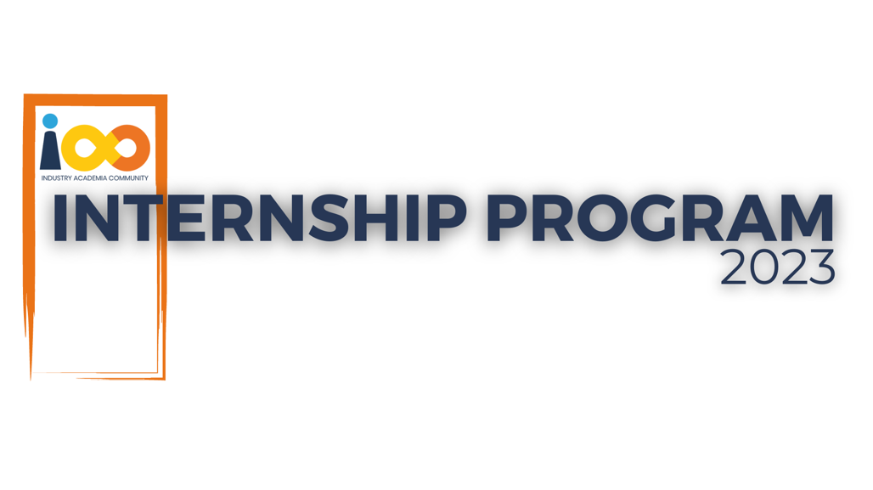

**IAC LIVE PROJECT PLAN**

DOMAIN NAME: DATA ANALYTICS  
  
PROJECT NAME: STUDENT DATA ANALYSIS

**Project Objective:**

The objective of this project is to conduct a comprehensive analysis of student interns to gain insights about the relationship between their academic performance, event participation, career aspiration and factors influencing their success.

**Project Scope:**1. Collect and analyse data related to student interns.2. Identify correlations and trends between academic performance, event participation, career aspirations, and success factors.3. Provide actionable insights and recommendations based on the analysis.

**Project Team:**

Project Team: Aarushi Bose

Project Name: Student Data Analysis

**Project Timeline:**

Start Date: 27/05/2024Submission Date: 28/06/2024

**Phase 1: Project Initiation (Week 1)**1. Define project objectives, scope, and deliverables.2. Form the project team.3. Identify data sources and access permissions.4. Develop a project schedule and timeline.5. Conduct a kick off meeting to communicate objectives and expectations.

**Phase 2: Data Collection (Week 1-2)**1. Collect and Analyse data on student interns, including academic records, event participation, career aspirations, and success factors.2. Ensure data privacy and compliance with relevant regulations.3. Verify data accuracy and completeness.4. Create a data repository for storage and organization.

**Phase 3: Data Analysis (Week 2-3)**1. Clean and preprocess the collected data.2. Perform exploratory data analysis (EDA) to identify initial trends and correlations.3. Create visualizations to present findings.4. Identify key insights and potential factors influencing student success.

**Phase 4: Report Generation (Week 3-4)**1. Compile analysis results into a comprehensive report.2. Summarize key findings, trends, and recommendations.3. Include data visualizations to support the analysis.4. Review and validate the report with stakeholders.5. Make any necessary revisions to the report.